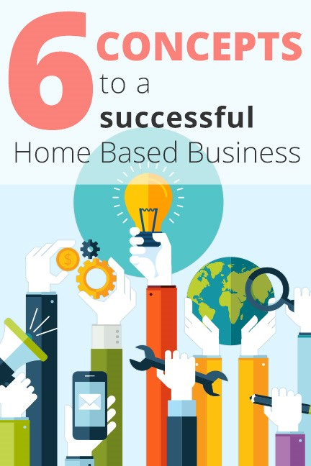

Six Concepts to a
Successful Home Business
What makes a successful Home Business?
Let's take a few minutes to analyze the six main concepts to success in any business. If you understand the concepts, and incorporate them in your home business, you have the potential for success beyond your wildest imagination!

Concept Number 1: Market Position
Which do you think would be a better market to tap into, typewriter sales, or personal computer sales? In this case its obvious, typewriters are obsolete, but personal computers and tablets are everywhere. Therefore, we know which of these markets is expanding and which one isn't. Even if you did make the right choice, you would still have to know how to effectively get your share of the business. Just hanging a sign on your door saying "PC's sold here" wouldn't enable you to effectively capture your share of the market.
So how do you position yourself in front of a "Huge Expanding Market"? First you need to identify the fastest growing industries. Some of the fastest growing industries today are:
- Working From Home - $401 Billion Dollar Industry.
- Internet Marketing - exceeds $523 Billion according to a study done by the McCombs School of Business and is expected to reach 7 Trillion within the next 3 years.
- Mail Order Marketing - $350 Billion Dollar Industry and growing.
- Wellness Industry - $200 Billion Dollar Industry and expected to reach $1 Trillion within 10 years.
- Nutrition Industry - $4.2 Billion Dollar Industry and exploding.
- Weight Control Industry - $33 Billion Dollar Industry fueled by epidemic size obesity levels. An estimated 70% of the U.S. population needs to lose 10 - 50 pounds.
- Personal Care Industry - $72 Billion Dollar Industry.
- Cosmetics Industry - $8 Billion Dollar Industry - and steadily growing.
Let's take a closer look at just one of those industries. In the early ninety's the Wall Street Journal estimated the total annual revenue from mail order marketing at between $55 and $65 billion dollars. Then the New York Times reported $140 billion a year. Then Direct Marketing Magazine reported $245 billion, and at the time this was written, the industry had grown to $350 billion, and it is expected to double in size in the next decade. If you had 1/3 of 1% of that market, you'd have over a billion dollars in sales. The Gartner Group estimates Internet business will triple in the next few years. Imagine owning a small piece of that!
Imagine positioning yourself in front of some of these industries listed, while working from home and utilizing the power of mail order and Internet Marketing to build your business.
So, let's look at the next concept...

Concept Number 2: Market an "Exclusive, Consumable" product
A consumable product is one that people use, and replace regularly. What that amounts to for the one providing the service or product is repeat business, repeat purchases, and a daily cash flow. Just think about that for a minute - every time someone turns on a light, someone makes money. Every time you pick up the telephone, someone makes money. Every time you eat, turn on the water, start your car, use a bar of soap, or get a haircut, someone makes money. A great example of this is breakfast cereal; this is a huge consumable product. Kellogg's does over $6.94 billion dollars a year in sales! Imagine millions of $3 or $4 sales several times a month, year after year, after year.
The ideal home business is one that offers consumable products or services in such a way that after your initial effort is done; repeat orders, sales and commissions come to you for the rest of your life.
Any consumable product is not enough. It has to be in high demand. It also has to be unique, exclusive and not readily available in stores. The ideal arrangement would be if the only way a consumer could get the product or service would be through you. The next concept will help you make the right choice of such exclusive products or services.

Concept Number 3: Take advantage of "Large, Enduring Trends"
A "Market Trend" is really an economic movement, meaning that large masses of people's spending habits are moving in a uniform direction. History shows that those who identify these trends early and are able to meet the needs of these trends, are able to create abundant wealth for themselves. They get in front of an economic wave and ride it to financial freedom! The key is timing. Get in front of the wave and take the ride of a lifetime; start too late and you're waiting for the next "Big Wave" to ride on. If you don't pay attention, you stand to miss out on a fortune.
So how can we predict such trends today? The key is to know the wants and needs of large consumer groups. 'Who are they?', and 'what do they want?' Current research shows, that what most people want out of life is feeding the current market trends:
- Owning Their Own Business
- Having Tax Advantages
- Being Financially Independent
- Being Healthy
- Having A Rewarding Career
- Owning Their Own Home
- Looking & Feeling Younger
- Improving Their Lifestyle
- Losing Weight
- Traveling
These are the wants and needs of some very large consumer groups. In fact, three very large trends are gathering momentum as you read this. They are so large that they can accurately be called "Mega-Trends". The combination of these Mega-Trends is causing one of the most explosive economic waves in history. It's this wave that our Work From Home Internet & Mail Order Business will help you ride.
Let's examine what's happening and why. The largest consumer group in recent history is called the "Baby Boomers". This segment of society was born between 1946 and 1964. Because of the large number of people identified as "Boomers", entire fortunes have been made by people who anticipated what these people wanted and were able to satisfy those wants. As this group matures, they are literally creating the first Mega-Trend that our system will help you "Tap" into.
First, let's explore the history of fortunes created by this economic Mega-Trend:
- Food - 10,000 babies born a day that needed to be fed for 18 years o Gerber cashed in
- Clothing - As they grew they needed to be clothed o Buster Brown got rich o Kinney Shoes cashed in
- Education - Schools were built o Elementary Schools Boomed o In the 60's 784 new Universities were built • Real Estate o The 70's and 80's saw the largest housing market in history
- Transportation o Little "boomers" needed a ride and Chrysler caught a wave with the mini van.
- In the 90's the "Boomers" started turning 50 at a rate of 10,000 per day and major trends developed: o They are concerned about their health o Worried about retirement
o They want to be healthier, look and feel younger
Any product that can genuinely help, that is consumable, is a highly prized item. This is what is fueling the worldwide trend toward wholesome, natural prevention, healing, weight control, and natural supplementation. Just look at the articles in magazines at the checkout counters and you'll see what I mean. You can't help but see articles on such issues, and if you watch TV, you know how many commercials are trying to address these Mega-Trend demands.
In recent years the mindset has shifted from using medications, toward natural approaches to good health. If we look at the fact that 70% of deaths worldwide are a result of stroke, heart disease, or cancer, and 50% of those are diet related, it's no wonder the "Wellness" industry is producing revenues in excess of $200 billion dollars per year. The desire to look younger and better is also fueling the $72 billion dollar a year personal care industry.
Another health issue today is people's weight. The Surgeon General of the United States reported that obesity has reached epidemic proportions. Nearly half of the population is clinically obese, and some estimates have stated that 80% of the population wants to lose five pounds or more. Obesity and related conditions are the second leading cause of death in the U.S. today, and the fastest growing segment of the overweight population is teenagers. This explains why the weight loss industry is doing over $33 billion dollars per year.
This means a massive economic wave is being fed by the aging Baby Boomers looking for natural, nutritional supplements as an approach to good health and weight control as well as the use of anti-aging types of personal care products creating Mega-Trend No. 1.
The dawn of a new millennium found us in the middle of another wave, the "Work from Home" trend which many believe is in it's infancy at $401 billion dollars per year. People want to take control of their lives, time and financial future. A statistical fact indicates that most heart attacks occur on Monday morning. Does this mean some people would rather die than go to work? At the time this was written, an estimated 14 million people work from home full time, and 13 million work from home part time in the U.S. alone. This number is increasing by almost 600,000 per year, and the average home-based business income is an estimated $50,000 per year, almost double the average income of an American employee! This trend is moving so fast, it is estimated by Home Incorporated magazine that 8,493 new home businesses are started every day. That's one every ten seconds! Will you be one of them? Is that why you're reading this eBook? We cater to that trend, and you can ride this wave with our system!
The final Mega-Trend, Internet Marketing, is projected to have a greater impact on the world than the Industrial Revolution. You can't watch TV, listen to the radio, read a newspaper, or even drive your car without being exposed to "Visit our website at www.whatever.com", now that's a significant trend, and with our system, you can capitalize on this even if you don't own a personal computer.
Now that we've explored the Mega-Trends, it's obvious why these industries we mentioned in Concept Number 1 are growing so fast. All these industries are built on
"Consumables" creating repeat business, Concept Number 2.
Now let's take a look at the fourth and most essential concept.

Concept Number 4: Leverage your time
Leverage allows us, as entrepreneurs, to build a successful business, part time, around our busy lifestyle. In essence, leveraging our time allows us to get more done in a shorter period of time with less effort. This concept applied in business means you can accomplish more than you could normally accomplish on your own. An example of this is a business owner who employs 100 people, leveraging his time 100 times. This means he can produce 100 times more than he could by himself. He also gets paid on the efforts of 100 employees. The problem with this is the arrangement does not allow for the employee to reap the benefits of leverage, and therefore they are not as productive as the business owner.
Another way to apply income generating leverage is through the use of technology. This allows one person to accomplish more than they could alone through the use of:
- Computers
- Websites
- Voicemail
- Videos
- CDs & DVD’s
When effectively incorporated into a home-based business, these tools can multiply leverage thousands of times. That means in the right system, technology can do the work of thousands of people, and you get paid on that work! Imagine developing a business part-time that wouldn't interrupt your present circumstances, and provide you a flow of income while you spend time with your family, travel, go to the beach, or even sleep! That's the power of leverage.
Leverage is absolutely critical for a successful home-based business in the beginning, and to enjoy a long lasting lifestyle. Your lifestyle is probably very fast paced and hectic already. Without proper leverage, you would have to be superhuman, or quit your current job to build a business, and I'm sure you'll agree that would be a bad move. You should first build your business to a level of financial strength, and then possibly consider leaving your current job.
Our system allows us to take advantage of the most powerful leveraging system because it applies both leveraging principles. Our automated system does an incredible amount of work for us, and it will do the same for you. Things like websites, automated customer follow-up programs. Unique one-of-a-kind Business Cards that drive large amounts of business for us so that we can travel, sleep, work or play, and our income continues and grows. The way our organization is structured, we literally leverage our efforts through each other.
We put a great deal of effort into building our businesses, but our system allows us to accomplish so much more for our efforts in a very short period of time. You can literally achieve a higher level of success in a few years, than most people do in an entire lifetime. Now that's leverage.

Concept Number 5: Product Fulfillment
Another key element is the ability to service your customers at a reasonable cost while maintaining reliability. With the power of the Internet this has become more important than ever before. Our suppliers have an international network of dozens of warehouses in many countries. This allows your customers to receive products shipped to them on your behalf. There is also a support structure and customer relations' hotline that your consumer group can call to have product related questions answered. This allows you to focus on your marketing efforts so you can work part time and earn a full time income.

Concept Number 6: Business Structure
The sad statistic is that most small, new businesses fail. Not because they aren't good, but because the people who start them aren't able to do everything that is required to be successful. Let's consider what is required to make a business successful:
- Sales
- Marketing
- Accounting
- Administration
- Product Development
- Order Fulfillment
- Product Delivery
- Taxes
- Customer Support
- Automation
- Data Management
- Staffing
- Training
- Attorney's
When you consider all of these aspects, succeeding in your own business seems like a difficult task.
With our system, you can focus on a couple of the aspects required for success, so you don't have to be good at everything. There is very little accounting related work, just keep simple records of sales and expenses. We have proven ready-to-use marketing and advertising systems. You won't need a staff. The suppliers handle product development, order fulfillment, and product delivery. They also track sales and pay commissions to you each month. Web site development, design, maintenance, and implementation are handled for you.
In a nutshell, our system allows you to focus on generating sales leads with our proven advertising methods, and allows you to process those leads with our successful mail order and Internet systems. In essence, we have eliminated the other areas of concern, so your chance of success is higher.
To wrap things up let's look at how our Home Marketing System measures up. It is important to know any system that effectively bundles these concepts together must still fit into successful marketing guidelines or it is destined for failure. According to the Direct Marketing Association, there are a few guidelines you must follow to succeed in marketing any product. Number one, always work with a product that you like, and believe in, but that product should also have one or more of the following characteristics:
- Broad appeal - Ideally, every man, woman, or household either wants or needs it.
- Exclusivity - The product or comparable products should not be available in stores. The only way the customer can get it is through you.
- Emotion - The product should significantly enhance or change the customer's life. For example: better health, more money, improved lifestyle.
- Easy to use
- Competitively priced
- Money-back guarantee
- Readily available
A business that provides one or more of these needs is likely to do well. What do you suppose would happen if your business provided for all of these? You would have a potential gold mine! Well our business does just that. So the ideal business would provide for all of these needs to a large group of people, not just locally, but internationally as well. The products would have to be easy to ship from your home or the supplier. They would have to be the best products available, at a competitive price, and comparable products would not be available anywhere else. The products should be consumable, so the customer would re-order, and you would want your supplier to be financially strong and stable with a good track record showing innovation and strength over a period of time. You would want that company to be on the cutting edge of technology, and far ahead of the competitors, staying in front of market needs. Now if that company would train you, support you, and perform administrative functions, wouldn't that be a serious advantage? Of course it would, now what if you could start that business without a huge financial investment? What if you didn't need any special tools, facilities, or skills to make a swift significant return on your initial investment? I would say you've found the ideal home based business. So maybe you're thinking there is no such opportunity like that out there. But you would have to admit; if it did exist it would definitely be worth taking a serious look. That is exactly the opportunity that you are looking at now.
Contact the person who gave this eBook to you and they can show you how our business utilizes these "Six Concepts to a Successful Home Business."
"When it comes to the future, there are three kinds of people: those who let it happen, those who make it happen, and those who wonder what happened." ~ John M. Richardson, Jr.
You can be one of those who make it happen by contacting the person who gave this eBook to you.
_______________________
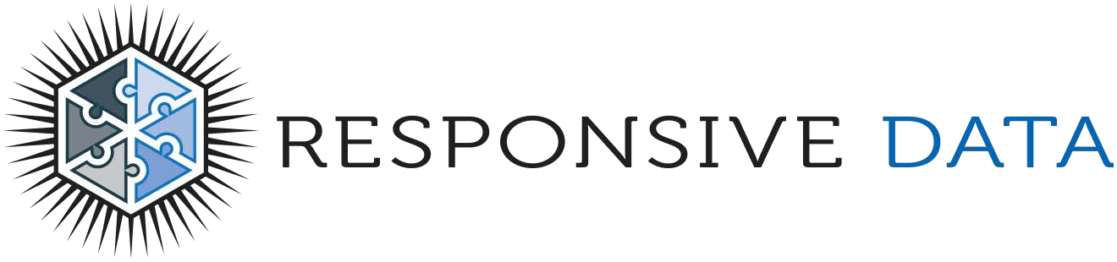
© 2016 Responsive Data. All rights reserved.

